

Mehran University of Engineering and Technology Jamshoro

**ASSIGNMENT : LAB 02**

**SUBJECT : PROGRAMMING FUNDAMENTALS**

**ROLL NO : 24BSAI29**

**SUBMITTED BY : SYED MUHAMMAD QASIM**

**SUBMITTED TO : MA’AM FAHAMA BARKZAI**

|  |
| --- |
| Department of Software Engineering  Mehran University of Engineering and Technology, Jamshoro |

|  |  |  |  |
| --- | --- | --- | --- |
| Course: AI-112 – Programming Fundamentals | | | |
| Instructor | Engr. Fahama Barakzai | **Practical/Lab No.** | 02 |
| Date |  | **CLOs** | 3 |
| Signature |  | **Assessment Score** | 01 Mark |

|  |  |
| --- | --- |
| Topic | C++ Primitive datatypes, Variables and Constants |
| Objectives | * To become familiar with C++ datatypes, such as int, char, float, etc. * Variable declaration, definition and initialization. Variable names/identifiers. * Output with cout: single character and other datatypes. Input with cin: * Escape sequences. |

|  |
| --- |
| Lab Discussion: Theoretical concepts and Procedural steps |

**TOOLS: TURBOO C++/ DEV C++/ VS-CODE/ CODE BLOCKS**

|  |
| --- |
| Lab Tasks |

1. Try to create a C++ program in which declare some variable with valid identifiers and naming conventions rule, to hold your name, your total marks in previous semester, percentage, your grade, your status of pass or fail, etc. assign them explicitly and print them. Try to declare variables of all data types and assign the appropriate values.

**C++ program to Declare and Print Variable:**

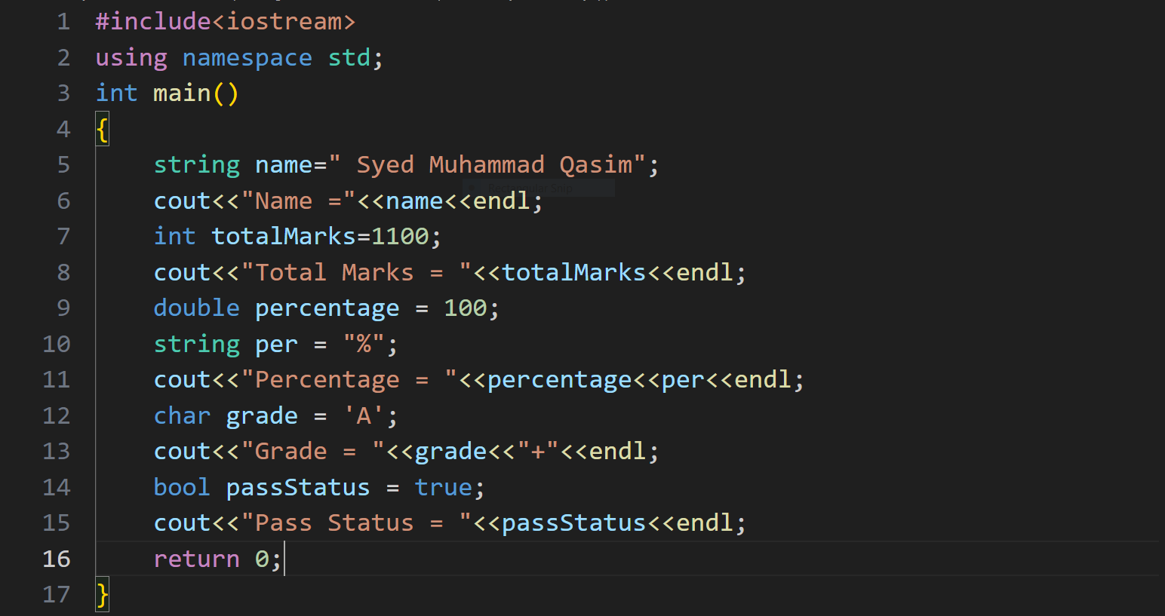

**Expected Result:**

The output of the program is:

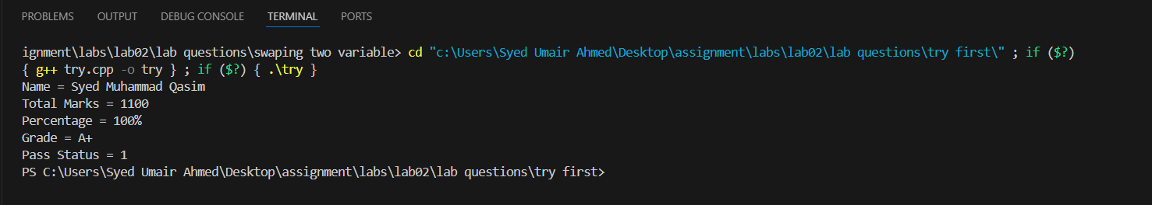

1. Practice a C++ program to swap two variables.

**C++ Program to Swap Two Variables:**

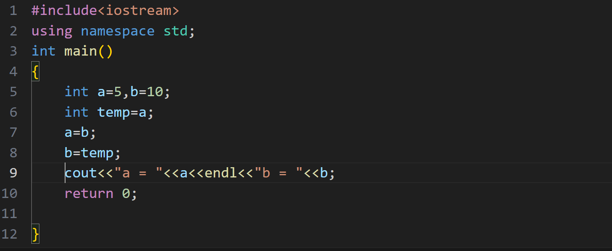

**Expected Result:**

The output of the program is:

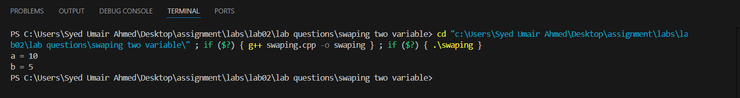

1. Rebuild a C++ program to print your name by giving the ASCII values of all the characters of your name.

**Expected code:** char a=65, b=66;

**Expected output:** AB (*your name in our case)*

**C++ Program to Print Name Using ASCII Values:**

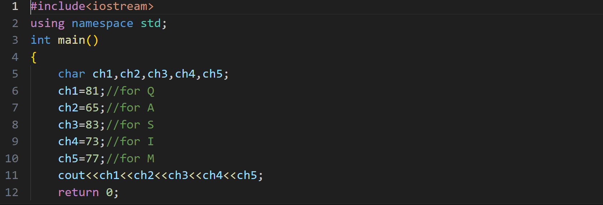

**Expected Result:**

The output of the program is:



1. Try to create a C++ program to find the size of fundamental data types.

***Hint:*** use sizeof (datatype) function.

**C++ program to find the size of fundamental data types:**

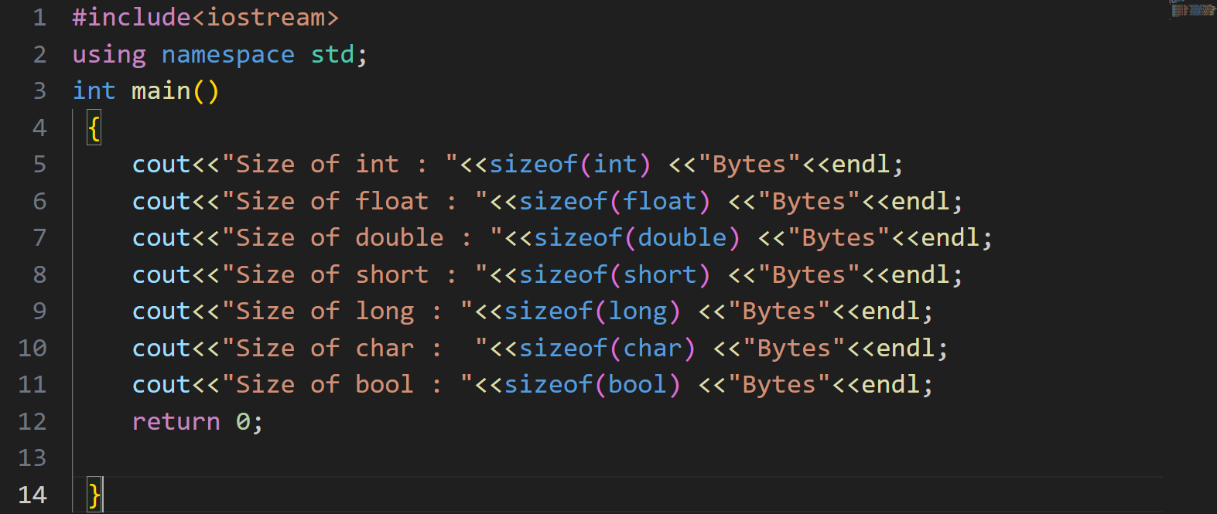

**Expected Result:**

The output of the program is:

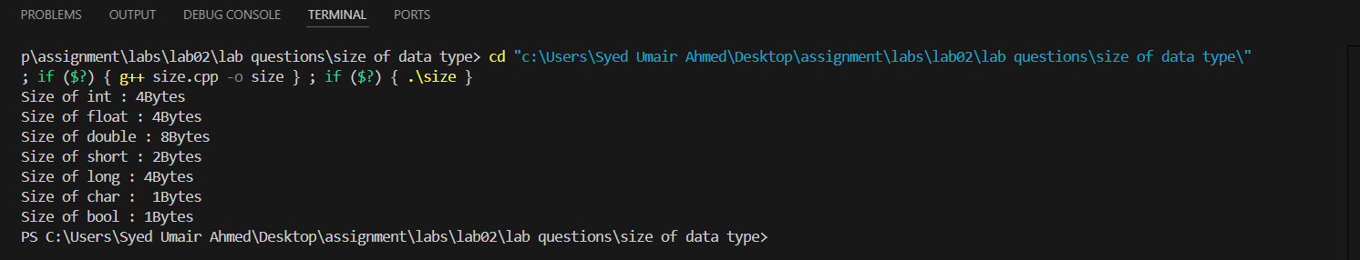

1. Practice a C++ program to print the following lines:

You are 10 years old.

You are too young to play the game (**Hint:** use an int variable for age).

**C++ Program to Print Specific Lines:**

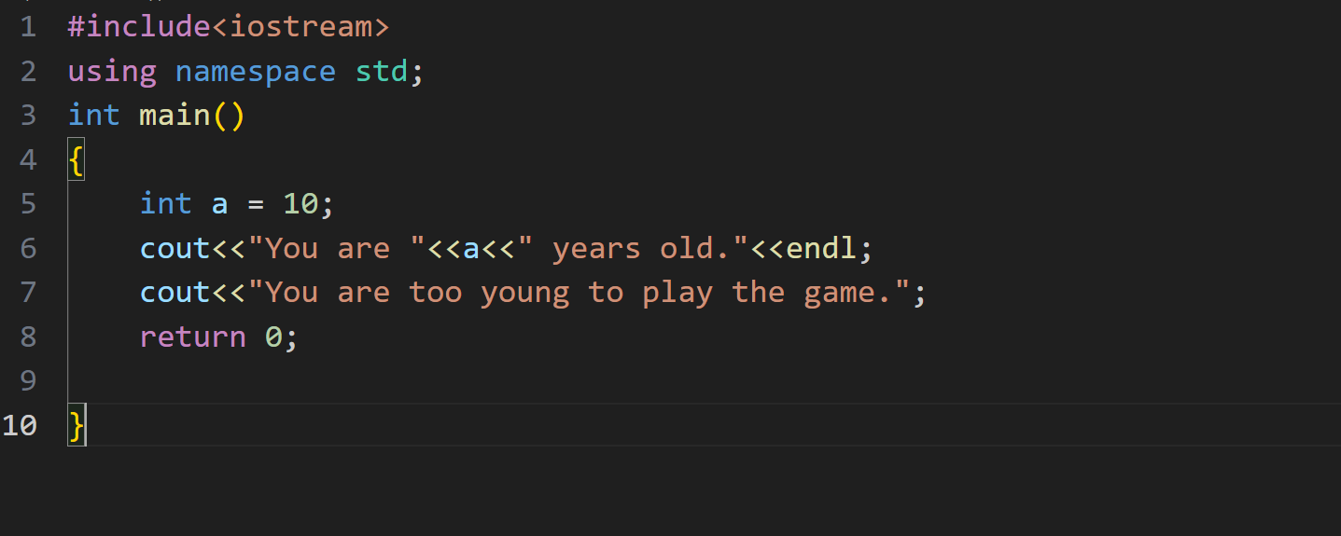

**Expected Result:**

The output of the program is:

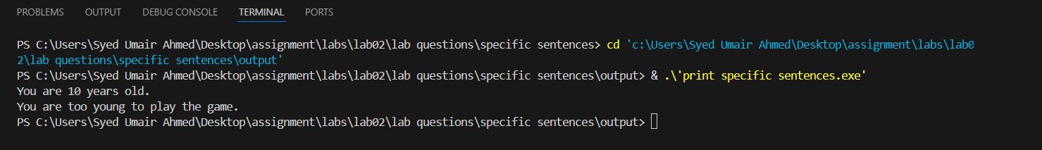

This is the end of the assignment. In this assignment, we practiced the basics of C++ programming. We wrote programs to declare and use variables, swap values, display text and character, and do simple calculations. These exercises gave us a good introduction to writing simple programs and understanding how C++ works.